GPSSA – Calendar Mart using SQL

**STEP - 1**

* Create a static view containing Citizen demographic and Employer demographics. This would be the DEMOGS_VIEW. (Ensure that there are no duplicates in this view).

**SQL - Query**

1. SELECT

a.Education, a.Gender, a.Job_changes, a.Master_Id, a.Stream, a.Unemployment_period, b.Age_of_establishment, b.Employer_id, b.Employer_type

INTO DEMOGS_VIEW

FROM dbo.MDM_demographics AS a LEFT JOIN dbo.MDM_employer_demographics AS b ON a.Master_Id = b.Master_Id;

**OUTPUT**

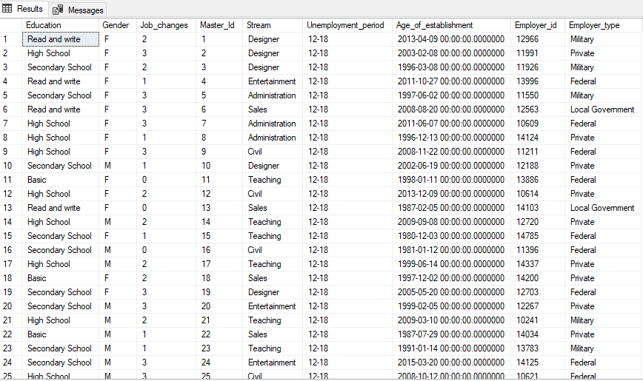

**STEP - 2**

* From the FTS data extract the individual elements from the string.

**SQL - Query**

1. UAE576PF:01_2019:11327.934464
2. 576 corresponds to Master_ID, 01_2019 corresponds to MMYY and 11327 corresponds to the Salary
3. Multiple salaries on the same month, one having negative or 0 entries might be there. Remove negative values and then aggregate all the salaries in the month. This will be your FTS_SALARY_VIEW having Master_id, MMYY,Salary without any duplicate entries

* CREATE TABLE FTS_SALARY_VIEW ( Master_id int, Event_time text, Salary float );
  + INSERT INTO FTS_SALARY_VIEW (Master_id, Event_time, Salary)
  + SELECT (SUBSTRING(F.column1, 4, CHARINDEX('P', F.column1) - 4)),
  + (SUBSTRING(F.column1, CHARINDEX(':', F.column1) + 1, 7)),
  + (try_convert(float, SUBSTRING(F.column1, CHARINDEX(':', F.column1) + 9, 100)))
  + FROM FTS AS F;
  + UPDATE FTS_SALARY_VIEW SET Salary = 0 FROM FTS_SALARY_VIEW WHERE Salary < 0;
  + SELECT CAST(Master_id AS NVARCHAR(100)) AS Master_id, CAST(Event_time As NVARCHAR(100)) AS Event_time,
    - SUM(Salary) AS Salary INTO FTS_SALARY_VIEW1
  + FROM FTS_SALARY_VIEW
  + GROUP BY CAST(Master_id AS NVARCHAR(100)),CAST(Event_time As NVARCHAR(100));

**OUTPUT**

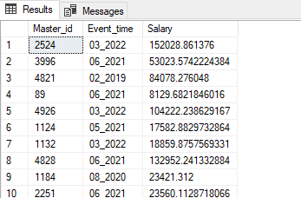

**STEP - 3**

* Repeat point 2.c for the Siebel salary. This will be your SIEBEL_SALARY_VIEW

**SQL - Query**

* UPDATE Siebel_salary SET Salary = 0 WHERE Attrib_11 = 'N';
  + SELECT CAST(Master_id AS NVARCHAR(100)) AS Master_id, CAST(MMYY As NVARCHAR(100)) AS MMYY,
  + SUM(try_convert(float, Salary)) AS Salary INTO SIEBEL_SALARY_VIEW FROM Siebel_salary
  + GROUP BY CAST(Master_id AS NVARCHAR(100)),CAST(MMYY As NVARCHAR(100));

**OUTPUT**

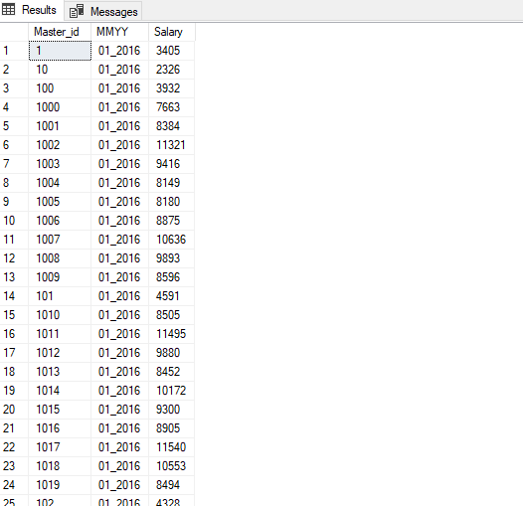

**STEP - 4**

* Remove duplicates for Siebel Contribution if any. This will be your SIBEL_CONTRIBUTION_VIEW

**SQL - Query**

SELECT CAST(Master_id AS NVARCHAR(100)) AS Master_id, CAST(MMYY As NVARCHAR(100)) AS MMYY,

SUM(try_convert(float,Contribution)) AS Salary INTO SIBEL_CONTRIBUTION_VIEW

FROM dbo.Siebel_contribution

GROUP BY CAST(Master_id AS NVARCHAR(100)),CAST(MMYY As NVARCHAR(100));

**OUTPUT**

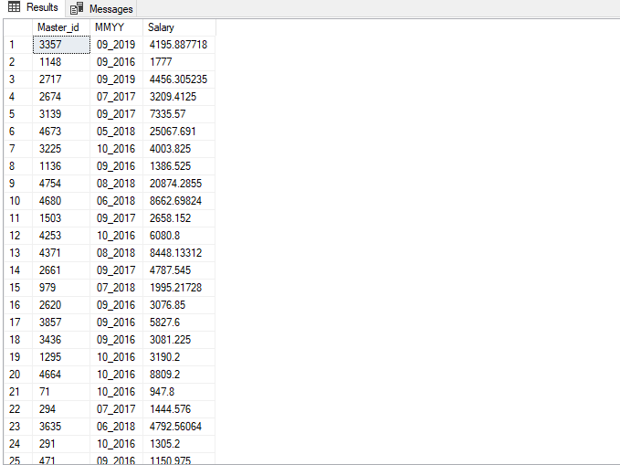

**STEP - 5**

* Create a contribution table from the FTS with the following logic

**SQL - Query**

1. Get the employer information from DEMOG_VIEW.
2. For govt and federal employees(anything except private employees) take it as 20% of the salary and for private employees take it as 17.5% of the salary. This will be your FTS_CONTRIBUTION_VIEW

SELECT

Master_id,Event_time,Salary

INTO fts_contribution_view

FROM dbo.FTS_SALARY_VIEW1;

alter table fts_contribution_view add contri float;

update fts_contribution_view set contri=salary*(.175) where master_id in (select master_id from MDM_employer_demographics where Employer_type ='Private');

update fts_contribution_view set contri=salary*(.2) where master_id not in (select master_id from MDM_employer_demographics where Employer_type ='Private');

select * from fts_contribution_view;

**OUTPUT**

